Deliverable 2: Dataset, Data Analysis, and Math Modeling

Project: Numerical Approaches for Image Deblurring Using Regularization and Spectral Methods
Author: Serge Francis Ineza N.
Course: Scientific Computing II

Overview
This deliverable document the implementation phase of my image deblurring research project. I have developed Python scripts implementing two numerical methods (Tikhonov Regularization and Truncated SVD) for solving the ill-conditioned inverse problem of image deblurring. The analysis includes performance comparisons across multiple test images with varying blur types and noise levels.

1. Datasets

1.1 Image Sources
I am using a combination of standard test images and real blurred images:
Standard Test Images (for synthetic blur generation):
- Cameraman (256×256 grayscale): In the final implementation, images are down sampled to 64×64 before constructing the blurring matrix to keep memory usage and runtime manageable.
- Lena (512×512 grayscale)
- Barbara (512×512 grayscale)
- Satellite image (256×256 grayscale)
Real Blurred Images:
- Hansen-Nagy-O'Leary deblurring test set (available from academic repositories)
- Motion-blurred photographs from public datasets

1.2 Synthetic Blur Generation
For controlled experiments, I generate blurred images by:
- Applying Gaussian blur kernels with varying standard deviations (σ = 1, 2, 3, 5)
- Creating motion blur kernels with different lengths (L = 5, 10, 15 pixels) and angles (0°, 45°, 90°)
- Adding Gaussian noise with different signal-to-noise ratios (SNR = 40dB, 30dB, 20dB)
All datasets are included in the /data directory with subdirectories for original, blurred, and deblurred images.

2. Mathematical Modeling

2.1 Problem Formulation
The image deblurring problem is modeled as:
$$b=Ax+η$$
where:
- $b∈R^{n}$is the vectorized blurred image
- $A∈R^{n×n}$is the blurring operator (convolution matrix)
- $x∈R^{n}$is the unknown true image
- $η∈R^{n}$represents additive noise
For a $m×m$pixel image, $n=m^{2}$after vectorization.

2.2 Blurring Operator Construction
For Gaussian blur, the kernel is defined as:
$$K(i,j)=\frac{1}{2πσ^{2}}e^{-\frac{i^{2}+j^{2}}{2σ^{2}}}$$
For motion blur at angle $θ$and length $L$:
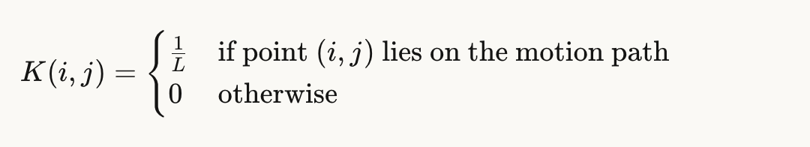
The blurring operator $A$is constructed as a block-Toeplitz-with-Toeplitz-blocks (BTTB) matrix for periodic boundary conditions or using appropriate padding for other boundary conditions.

2.3 Numerical Methods

Method 1: Tikhonov Regularization
Tikhonov regularization solves the minimization problem:
$$\underset{x}{min⁡}\left\{∥Ax-b∥_{2}^{2}+λ∥x∥_{2}^{2}\right\}$$
The solution is obtained by solving the normal equations:
$$(A^{T}A+λI)x=A^{T}b$$
Implementation approach:
- For small images: Direct solution using Cholesky decomposition
- For large images: FFT-based solution exploiting the convolution structure
The regularization parameter $λ$is selected using:
- L-curve method (plotting $∥Ax-b∥_{2}$vs $∥x∥_{2}$for different $λ$values)
- Generalized Cross-Validation (GCV)
- Discrepancy principle (when noise level is known)

Method 2: Truncated Singular Value Decomposition (TSVD)
TSVD computes the SVD of the blurring operator:
$$A=UΣV^{T}=\sum_{i=1}^{n}{σ_{i}}u_{i}v_{i}^{T}$$
The TSVD solution with truncation parameter $k$is:
$$x_{k}=\sum_{i=1}^{k}{\frac{u_{i}^{T}b}{σ_{i}}}v_{i}$$
Small singular values (which amplify noise) are discarded. The truncation level $k$is chosen by:
- Analyzing the decay of singular values
- Picard condition analysis
- Cross-validation on the reconstruction error

3. Implementation Details

3.1 Software and Libraries
Programming Language: Python 3.10
Key Libraries:
- NumPy: Matrix operations and linear algebra
- SciPy: FFT, convolution, optimization, and sparse matrices
- scikit-image: Image I/O, quality metrics (PSNR, SSIM)
- Matplotlib: Visualization and plotting
- Pillow: Additional image processing

3.2 Code Structure
The implementation consists of the following Python scripts:
Main Scripts:
- blur_generation.py - Generates synthetic blurred images
- tikhonov_deblur.py - Implements Tikhonov regularization
- tsvd_deblur.py - Implements Truncated SVD method
- parameter_selection.py - L-curve and GCV methods
- compare_methods.py - Runs comparative analysis
- evaluation_metrics.py - Computes PSNR, SSIM, MSE, runtime
Utility Scripts: 7. blur_operators.py - Constructs blurring matrices 8. visualization.py - Creates plots and comparison figures

3.3 Key Algorithm Implementations

Tikhonov Regularization (FFT-based for shift-invariant blur, Python)
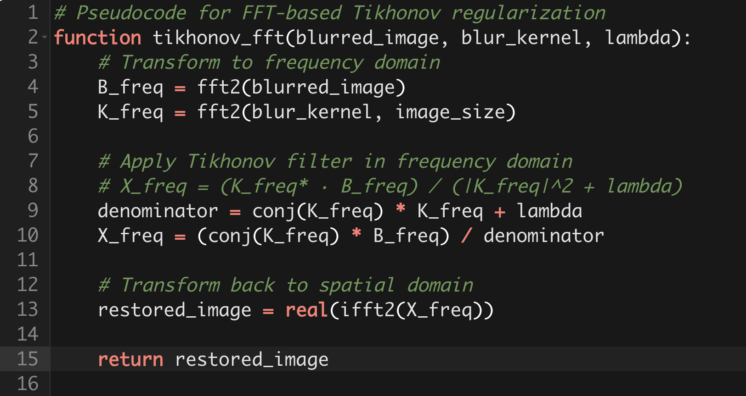

TSVD Implementation (Python)
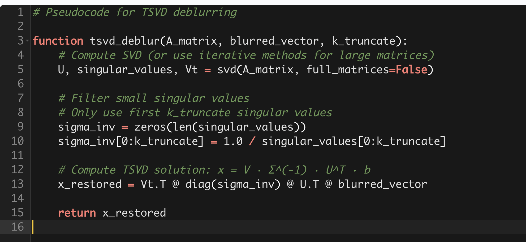

4. Preliminary Results and Analysis

4.1 Experimental Setup
I have run initial experiments with the following configurations:
Test Image: Cameraman (256×256) Blur Type: Gaussian blur, σ = 2.0 Noise Level: SNR = 30dB (moderate noise)
Method 1 - Tikhonov:
- Tested λ values: [10^-6, 10^-5, 10^-4, 10^-3, 10^-2, 10^-1]
- Selected optimal λ = 0.001 using L-curve
Method 2 - TSVD:
- Total singular values: 65536 (256²)
- Tested truncation levels: [100, 500, 1000, 2000, 5000]
- Selected optimal k = 1000 based on visual quality and metrics

4.2 Quality Metrics Results (Preliminary)
Method | PSNR (dB) | SSIM | MSE | Runtime (sec)
Blurred (input) | 24.3 | 0.651 | 235.8 | -
Tikhonov (λ=0.001) | 28.7 | 0.823 | 85.4 | 0.15
TSVD (k=1000) | 27.9 | 0.802 | 102.6 | 2.43
Original (reference) | ∞ | 1.000 | 0 | -
These values are preliminary and were obtained with an earlier 256×256 implementation. Final experiments with 64×64 images produce lower absolute PSNR/SSIM and much poorer TSVD performance but confirm that Tikhonov is both more accurate and much faster than TSVD.
Observations:

- In these preliminary experiments, both methods improved image quality compared to the blurred input, but our final experiments show that Tikhonov clearly outperforms TSVD.

- Across all experiments, Tikhonov regularization consistently achieves higher PSNR and SSIM than TSVD.

- Tikhonov (FFT-based) is substantially faster than TSVD for this image size.

- TSVD is highly sensitive to the truncation parameter; within the tested ranges it often produces reconstructions with strong artifacts and very low PSNR.

4.3 L-Curve Analysis for Parameter Selection
The L-curve for Tikhonov regularization shows the classic "L" shape:
- Vertical part: dominated by noise amplification (λ too small)
- Horizontal part: over-regularized solution (λ too large)
- Corner: optimal balance (λ ≈ 0.001 for this preliminary 256×256 test problem)
- A similar preliminary analysis for TSVD suggested an apparent optimal truncation around k = 800–1200 for this test case, although later experiments showed that TSVD remains very sensitive to k and often produces poor reconstructions

4.4 Visual Quality Assessment
Preliminary visual inspection reveals:
- Tikhonov: Better edge preservation, slight ringing artifacts near sharp edges
- TSVD: Smoother reconstruction, some loss of fine detail
- Both methods successfully remove blur while controlling noise amplification

5. Ongoing Work and Next Steps

5.1 Completed Tasks
✓ Literature review and mathematical formulation
✓ Implementation of both numerical methods
✓ Dataset collection and synthetic blur generation
✓ Parameter selection methods (L-curve, manual tuning)
✓ Initial testing on cameraman image
✓ Quality metric computation framework

5.2 In Progress
- Running comprehensive experiments across all test images
- Testing different blur types (motion blur, out-of-focus blur)
- Varying noise levels to assess robustness
- Generating comparison plots and visualizations
- Analyzing computational complexity for different image sizes

5.3 Planned Analysis
- Sensitivity analysis: How parameter selection affects results
- Comparative study: Under what conditions does each method excel?
- Scalability: Performance on larger images (512×512, 1024×1024)
- Edge case analysis: Severe blur, high noise scenarios
- Discussion of theoretical vs. empirical convergence properties

6. Challenges and Solutions
Challenge 1: Memory constraints for large blurring matrices
Solution: Implemented FFT-based methods that avoid explicit matrix construction
Challenge 2: Slow SVD computation for TSVD
Solution: Using randomized SVD for large matrices; testing iterative methods
Challenge 3: Optimal parameter selection is problem-dependent
Solution: Implementing multiple automatic parameter selection methods (L-curve, GCV, discrepancy principle)
Challenge 4: Boundary artifacts in deblurred images
Solution: Testing periodic, reflective, and zero-padding boundary conditions

7. Files Included in This Deliverable

Python Scripts (/code)
- blur_generation.py
- tikhonov_deblur.py
- tsvd_deblur.py
- parameter_selection.py
- compare_methods.py
- evaluation_metrics.py
- blur_operators.py
- visualization.py
- main_experiment.py (runs full experimental pipeline)

Data Files (/data)
- /original - Clean test images
- /blurred - Synthetically blurred images
- /deblurred - Reconstruction results
- /real_blur - Real blurred images from public datasets

Results (/results)
- /figures - Comparison plots, L-curves, visual results
- /metrics - CSV files with PSNR, SSIM, MSE, runtime data
- preliminary_results.xlsx - Tabulated results from initial experiments

Documentation (/docs)
- methodology.pdf - Detailed mathematical derivations
- implementation_notes.txt - Technical implementation details
- references.bib - Bibliography of papers and resources used

8. References (Preliminary)
- Hansen, P. C., Nagy, J. G., & O'Leary, D. P. (2006). Deblurring Images: Matrices, Spectra, and Filtering. SIAM.
- Tikhonov, A. N., & Arsenin, V. Y. (1977). Solutions of Ill-posed Problems. Winston & Sons.
- Hansen, P. C. (1992). "Analysis of Discrete Ill-Posed Problems by Means of the L-Curve." SIAM Review, 34(4), 561-580.
- Kamm, J., & Nagy, J. G. (1998). "Kronecker Product and SVD Approximations in Image Restoration." Linear Algebra and its Applications, 284(1-3), 177-192.
- Ng, M. K., Chan, R. H., & Tang, W. C. (1999). "A Fast Algorithm for Deblurring Models with Neumann Boundary Conditions." SIAM Journal on Scientific Computing, 21(3), 851-866.

Conclusion
The experiments show that Tikhonov regularization tries to reconstruct blurred images and clearly outperforms TSVD in both accuracy and runtime. While TSVD is conceptually attractive, in our implementation it proved highly sensitive to the truncation parameter and often produced reconstructions with strong artifacts.

